Satellites
  - By Nate Salisbury
Spring 2010

Astronomy Satellites

Hubble Telescope

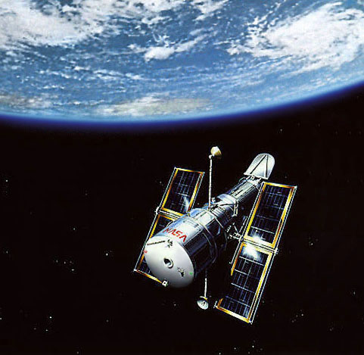
http://www.diskinserted.com/wp-content/uploads/2009/04/hubble_telescope.jpg

Dimensions:
- 43.5 ft. long
- Maximum diameter: 14 ft.

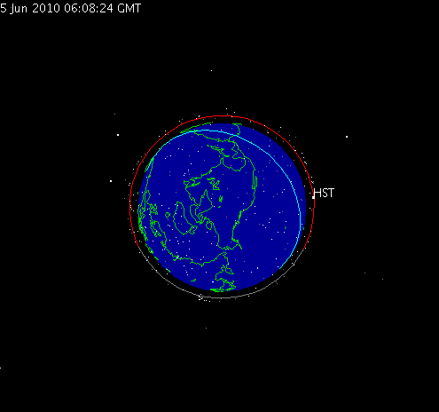
http://science.nasa.gov/realtime/jtrack/3d/jtrack3d.html

Orbit:
- Altitude 351.5 miles
  - Lower earth orbit

Navigation Satellites

Navstar-24 in orbit today

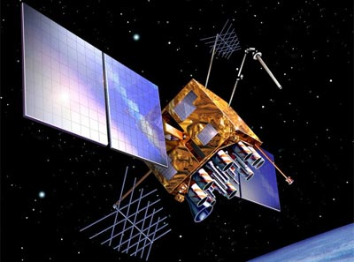
http://lanzamientos.files.wordpress.com/2009/08/navstar-2rm__1.jpg

Dimensions:
- The box shape is:
  - 6’ 2” x 6’ 3” x 4’ 9”

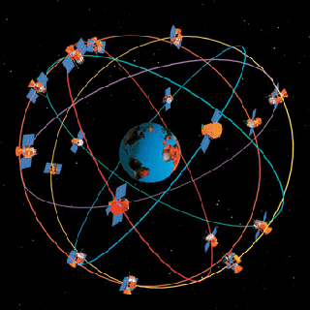
http://www.aero.org/publications/crosslink/summer2002/images/01_01.gif

Orbit:
- 12,500 Miles above earth
  - Middle earth orbit

Communication Satellites

KODAMA

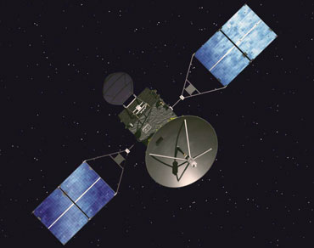
http://www.jaxa.jp/projects/sat/drts/index_e.html

Dimensions:
- The box shape is:
  - 7’ 2” x 7’ 8” x 7’ 2”
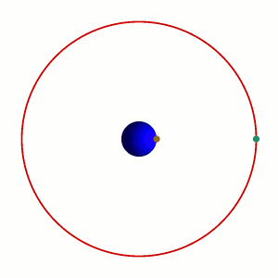
http://en.wikipedia.org/wiki/Communications_satellite

Orbit:
- Geosynchronous
  - About 22,300 Miles above earth
  - Is always above the same point of earth.
    - To us on earth it appears to not move.

References:
- http://www.satellites.spacesim.org/english/engineer/copy/index.html
- http://www.diskinserted.com/wp-content/uploads/2009/04/hubble_telescope.jpg
- http://science.nasa.gov/realtime/jtrack/3d/jtrack3d.html
- http://lanzamientos.files.wordpress.com/2009/08/navstar-2rm__1.jpg
- http://www.aero.org/publications/crosslink/summer2002/images/01_01.gif
- http://www.jaxa.jp/projects/sat/drts/index_e.html
- http://en.wikipedia.org/wiki/Communications_satellite
- http://www.deagel.com/C3ISTAR-Satellites/GPS-Block-IIR_a000238003.aspx

